### Model Context:

MSE Loss

LSTM Model

Univariate Data (‘unrate’)

Split Training/Validation/Test from Start-2000/2001 to 2020/2021 respectively

### Scenario 1:

Hyperparameters:

| hidden_size | num_layers | Learning rate | sequence_length | num_epochs |
| --- | --- | --- | --- | --- |
| 64 | 1 | 0.0005 | 9 | 100 |

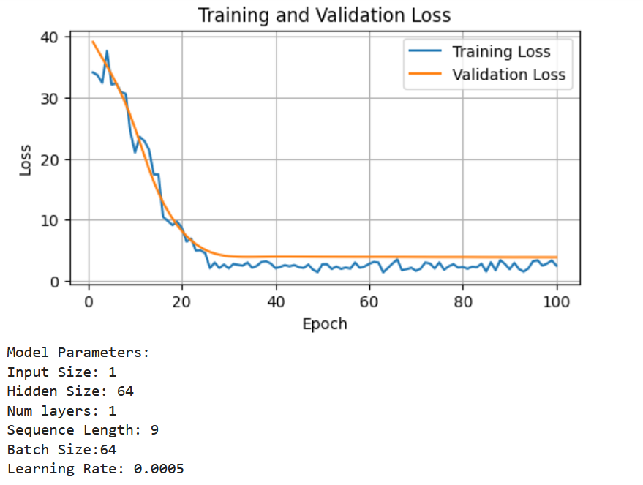

Evaluation:

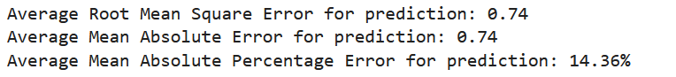

### Scenario 2:

| hidden_size | num_layers | Learning rate | sequence_length | num_epochs |
| --- | --- | --- | --- | --- |
| 64 | 2 | 0.0005 | 9 | 100 |

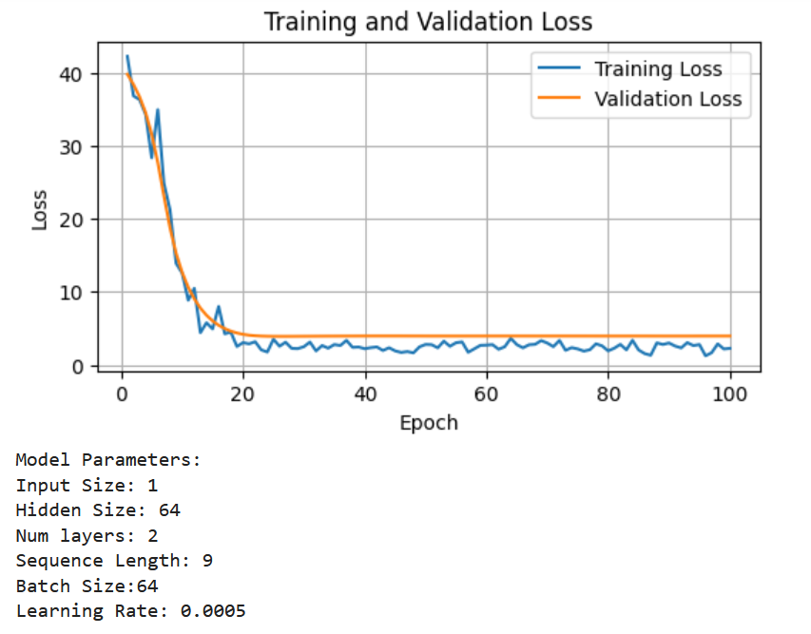

Evaluation:

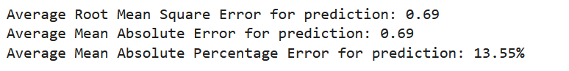

### 

### Scenario 3:

| hidden_size | num_layers | Learning rate | sequence_length | num_epochs |
| --- | --- | --- | --- | --- |
| 128 | 1 | 0.0005 | 9 | 100 |

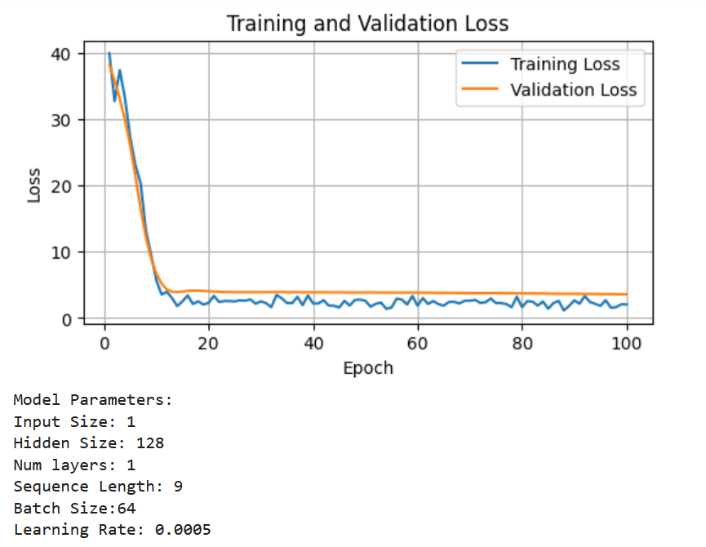

Evaluation:

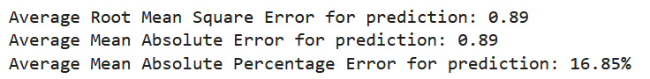

### 

### Scenario 4:

| hidden_size | num_layers | Learning rate | sequence_length | num_epochs |
| --- | --- | --- | --- | --- |
| 128 | 2 | 0.0005 | 9 | 100 |

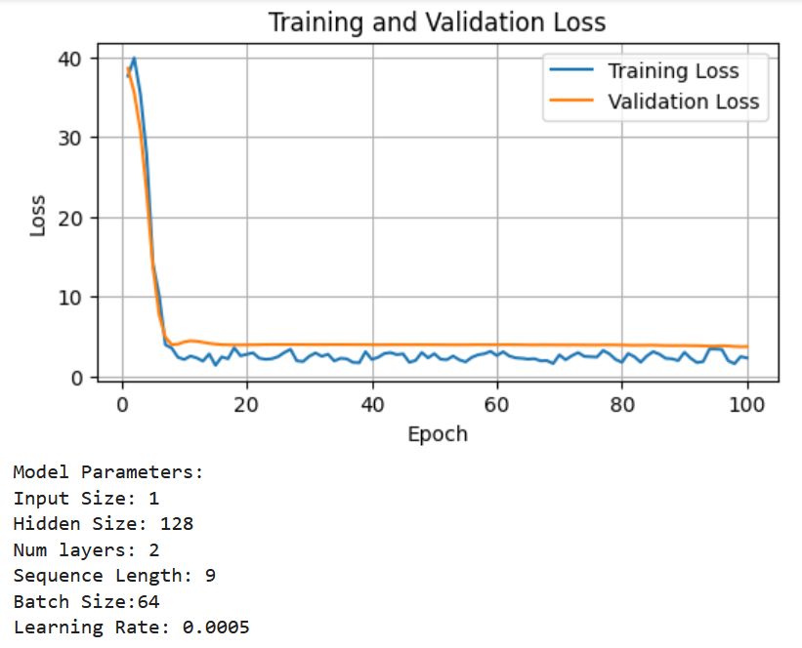

Evaluation:

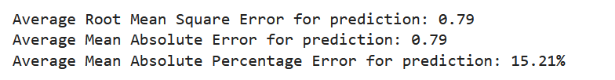

### Scenario 5:

| hidden_size | num_layers | Learning rate | sequence_length | num_epochs |
| --- | --- | --- | --- | --- |
| 64 | 1 | 0.00025 | 9 | 100 |

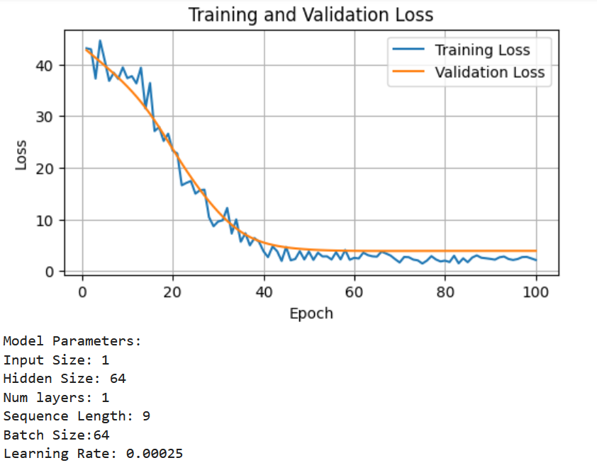

Test:

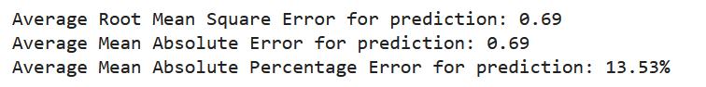

### Scenario 6:

| hidden_size | num_layers | Learning rate | sequence_length | num_epochs |
| --- | --- | --- | --- | --- |
| 64 | 1 | 0.00005 | 9 | 100 |

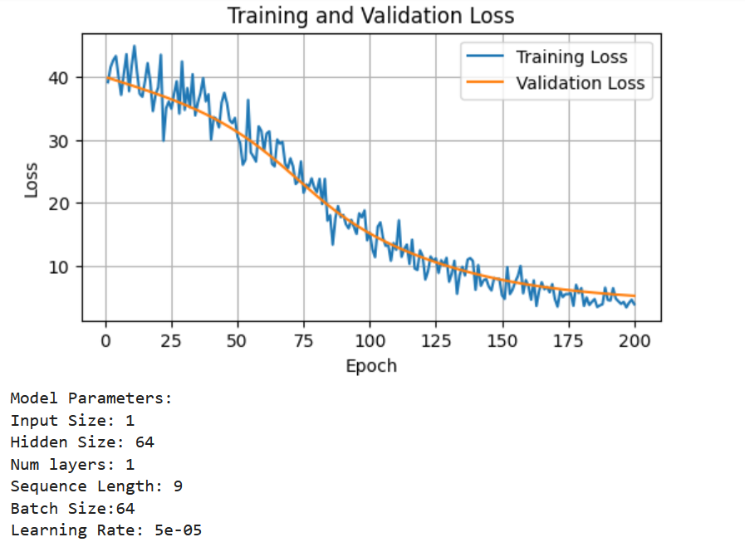

Test:

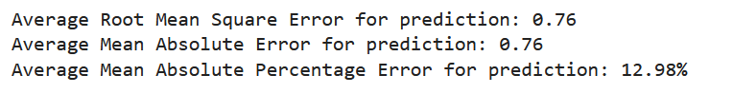

### Scenario 7:

| hidden_size | num_layers | Learning rate | sequence_length | num_epochs |
| --- | --- | --- | --- | --- |
| 64 | 1 | 0.00010 | 9 | 100 |

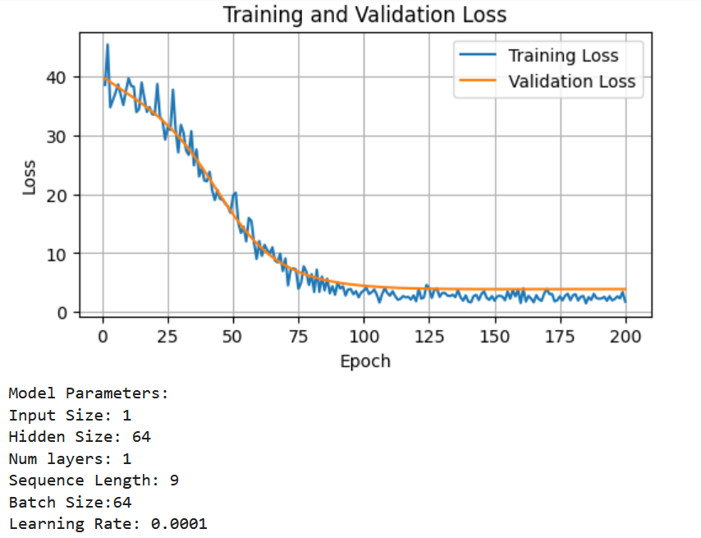

Test:

